**Heuristic Evaluation Report**

Date: 4/4/2021

Prepared By (team member names): Kiauna Newman

***Evaluation***

Name of website being evaluated: pvpat.om

Describe the scenario you used to focus your evaluation: PM Patti wants to cancel or change subscription.

**Problem #1**

Cancel button for Subscription

Insert print screen, location of problem:



Name of heuristic: User Control and Freedom

Reason for reporting negative or positive: User may want to cancel subscription without clicking on the update button.

Scope of problem: canceling subscription

Severity of problem (high/medium/low): low

Justification for severity rating: User will still be able to make changes by clicking on the update button. Someone who is short on time would like a quicker option to cancel the subscription.

Suggestions to fix: Adding a cancel or pause button will give the user the freedom to exit the subscription plan if they need to.

Possible trade-offs (why fix might not work): when the user clicks update, on the update screen, adding options to cancel or change subscription would also be helpful.

**Problem #2**

Adding hyperlinks to actions

Insert print screen, location of problem:

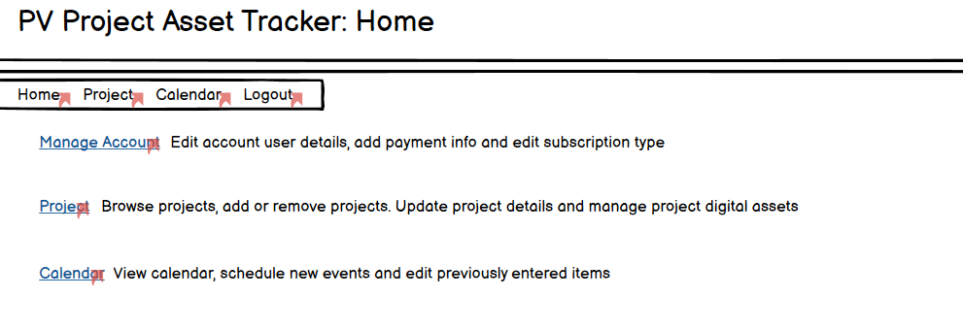

Name of heuristic: Flexibility and Efficiency of Use

Reason for reporting negative or positive: User can view options and know what they action they can complete, but if the options had links it would make it easier for a novice user.

Scope of problem: Home page options/actions

Severity of problem (high/medium/low): low

Justification for severity rating: User can click on link and go to page to complete desired action, but it would be quicker if there were hyperlinks on the home page for each actions.

Suggestions to fix: Ex) Change browse projects or add/remove projects to hyperlinks so that the User can click on the link and go directly to page.

Possible trade-offs (why fix might not work): Include a drop-down menu may be easier